Set 1

- Write a Python program to solve 8-Puzzle problem (Given a 3×3 board with 8 tiles (every tile has one number from 1 to 8) and one empty space. The objective is to place the numbers on tiles to match the final configuration using the empty space)

- Write a Python program to solve the 8-Queens problem of placing 8 chess queens on an 8×8 chessboard so that no two queens threaten each other.

- Write a Prolog Program for Student, Teacher and Sub-Code using following facts.
Studies (charlie, csc135).
Studies (olivia, csc135).
Studies (jack, csc131).
Studies (arthur, csc134).
Teaches (kirke, csc135).
Teaches (collins, csc131).
Teaches (collins, csc171).
Teaches (juniper, csc134).
Professor (X, Y) :- teaches(X, C),
Studies (Y, C).

- Write a Prolog program to solve Towers of Hanoi with mathematical puzzle where we have three rods (A, B, and C) and N disks. Initially, all the disks are stacked in decreasing value of diameter and smallest disk is placed on the top and they are on rod A.

Set 2

- Write a Python program for Water Jug problem with given two jugs, a 4-gallon one and a 3-gallon one. Neither has any measuring mark on it. There is a pump that can be used to fill the jugs with water. How can you get exactly 2 gallons of water into the 4-gallon jug.

- Write a Python program for Crypt-Arithmetic problem with digits (0 to 9) get substituted by some possible alphabets or symbols. The task in crypt arithmetic problem is to substitute each digit with an alphabet to get the result arithmetically correct.

- Write a Prolog program to print particular bird can fly or not using following facts.
Bird (eagle).
Bird (sparrow).
Bird (penguin).
Fly (penguin) :- !, fail.
Fly(X) :- bird(X).

- Write a Prolog program to implement family tree with the following given facts.
Pam, Liz, Ann and Pat are female, while Tom, Bob and Jim are male persons. Using this information, define the following relations:
Define the “mother” relation:
Define the “father” relation:
Define the “grandfather” relation:
Define the “grandmother” relation:
Define the “sister” relation
Define the “brother” relation

Set 3

- Write the Python program for Missionaries Cannibal problem. In the missionaries and cannibals problem, three missionaries and three cannibals must cross a river using a boat which can carry at most two people, under the constraint that, for both banks, if there are missionaries present on the bank, they cannot be outnumbered by cannibals (if they were, the cannibals would eat the missionaries). The boat cannot cross the river by itself with no people on board.

- Write the Python program to implement Travelling Salesman problem, given a list of cities and the distances between each pair of cities, what is the shortest possible route that visits each city exactly once and returns to the origin city.

- Write a Prolog program to implement the best sequence of actions for the monkey? A monkey is in a room. Suspended from the ceiling is a bunch of bananas, beyond the monkey's reach. However, in the room there are also a chair and a stick. The ceiling is just the right height so that a monkey standing on a chair could knock the bananas down with the stick. The monkey knows how to move around, carry other things around, reach for the bananas, and wave a stick in the air.

- Write a Prolog program for forward Chaining. As per the law, it is a crime for an American to sell weapons to hostile nations. Country A, an enemy of America, has some missiles, and all the missiles were sold to it by Robert, who is an American citizen. Prove that "Robert is criminal."
Set 4

- Write a Python program to solve vacuum cleaner world problem for the following test cases.
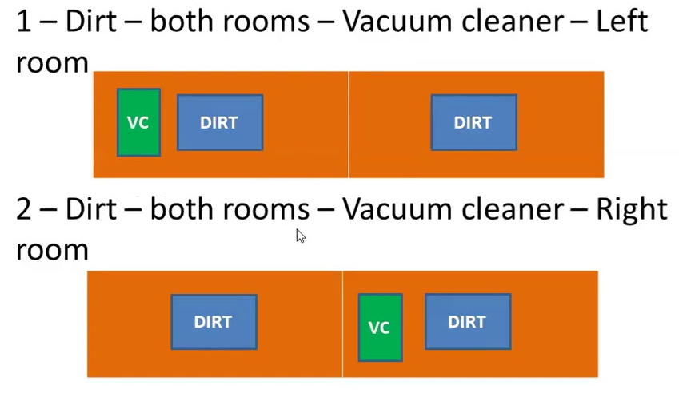
- Write a Python program to implement Breadth First Search technique for the given state space graph.
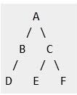
- Write a Prolog program with Name, DOB with for following required facts.
born(jan, 20,3,1977).
born(jeroen, 2,2,1992).
born(joris, 17,3,1995).
born(jelle, 1,1,2004).
born(jesus, 24,12,2000).
born(joop, 30,4,1989).
born(jannecke, 17,3,1993).
born(jaap, 16,11,1995).
- Write a Prolog program with FName, SName, Sex, Age and Occupation
person(frances,wilson,female,28,architect).
person(fred,jones,male,62,doctor).
person(paul,smith,male,45,plumber).
person(martin,williams,male,23,chemist).
person(mary,jones,female,24,programmer).
person(martin,johnson,male,47,solicitor).
man(A):-person(A,B,male,C,D).

Set 5
- Write a Python program for uniform cost search to solve the tree starting from S as initial node reach the goal node G

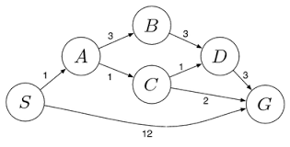
- Write a Python program to build a Vacuum World with simple reflex agent for the A and B squares as shown in the following figure.
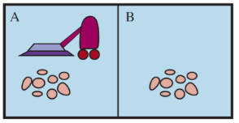
- Write a Prolog program with the following facts, Dog-Name, Size-Small, Medium and Big
dog (fido), dog(rover), dog(jane), dog(tom), dog(fred), dog(henry), dog(fido), cat(mary), cat(harry), cat(bill), cat(steve), small(henry), medium(harry), medium(fred), large(fido), large(mary), large(tom), large(fred), large(steve), large(jim), large(mike).

- Write a Prolog program for a Planets Database with the following facts.
orbits(mercury, sun).
orbits(venus, sun).
orbits(earth, sun).
orbits(mars, sun).
orbits(moon, earth).
orbits(phobos, mars).
orbits(deimos, mars).

Set 6

- Write a Python program, to calculate the optimal solution using Manhattan distance for the given 8 puzzle problem.

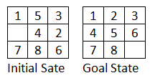

- Write a Python program, to evaluate the 8-Queens problem using Genetic algorithms. Propose a chromosome representation and crossover and mutation mechanisms that generate result in exactly one queen per column and one queen per row.

- Write a Prolog program for the forward chaining using following facts
rainy(chennai).
rainy(coimbatore).
rainy(ooty).
cold(ooty).

- Write a Prolog program to predict Fruits and its color using Backtracking
colour(cherry, red).
colour(banana, yellow).
colour(apple, red).
colour(apple, green).
colour(orange, orange).
colour(X, unknown).

Set 7

- Write a Python program to implement Depth First Search technique for the given state space graph.
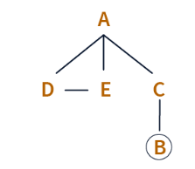
- Write a Python Program for Minimax search tree starting from this state, and ending in terminal nodes. Show the utility value for each terminal node. Also show which move the Minimax Algorithm decides to play. Utility values are +1 if X wins, 0 for a tie, and -1 if O wins. Assume that O makes the next move (O is the MAX player), use theTic-Tac-Toe board state as shown below

- Write a Prolog program to implement pattern matching with the following facts.
first_name(tonyblair, tony).
first_name(georgebush, georgedubya).
second_name(tonyblair, blair).
second_name(georgebush, bush).
- Write a Prolog program to implement Family Relation with the following facts.
female(sarah), female(rebekah), female(hagar_concubine).
female(milcah), female(bashemath), female(mahalath).
female(first_daughter), female(rachel), female(labans_wife).
male(terah), male(abraham), male(nahor).
male(haran), male(isaac), male(ismael).
male(uz), male(kemuel).\

Set 8

- Write a Python program for the following game tree using Alpha-Beta Pruning.

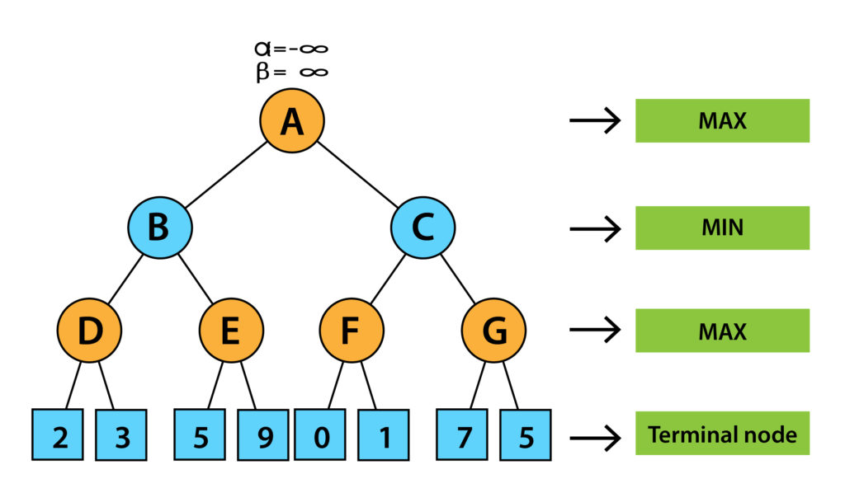

- Design a web page of your own to show how Anchor tags and titles are optimized by Search Engine Optimization.

- Write a Prolog program to find items and its location using following facts
location(desk, office).
location(apple, kitchen).
location(flashlight, desk).
- Write a Prolog program to predict the Causes of Disease with the following predicates and clauses.
predicates
hypothesis(name,disease)
symptom(name,indication)
clauses
symptom(amit,fever).
symptom(amit,rash).

Set 9

- Write a Python program to implement a Map Colouring problem with the following data. Given a map of countries, and a fixed set of colours {Red, Green, Blue}, assign a colour to each region in the map in such a way that no two adjacent regions have the same colour. Solve the above Map Colouring problem using backtracking in Constraint Satisfaction Procedure.
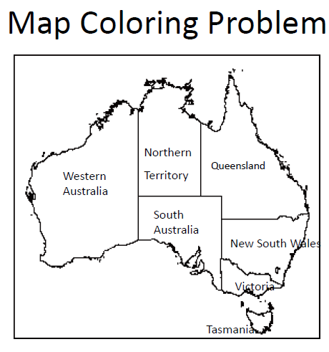
- Write a Python program to apply A* search for the given tree, in which ‘A’ is the initial state and ‘E’ goal state. For each node in each stage, obtain cost estimates where g(n) is the numeral by the side of an arc and h(n) is the numeral at the node.
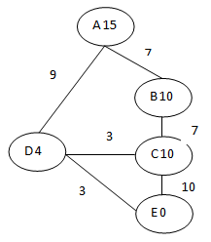
- Write a Prolog program to implement Inference Engine with the following facts
interpret(true) :- !.
interpret((GoalA,GoalB)) :- !,
interpret(GoalA),
interpret(GoalB).

- Write a Prolog program to find the number of vowels in the following fact.
This is my first Degree in Saveetha School of Engineering.

Set 10
- Write a Python program to apply a Decision Tree for the following problem’s training dataset. Problem: Decide the customer will buy the computer or not.

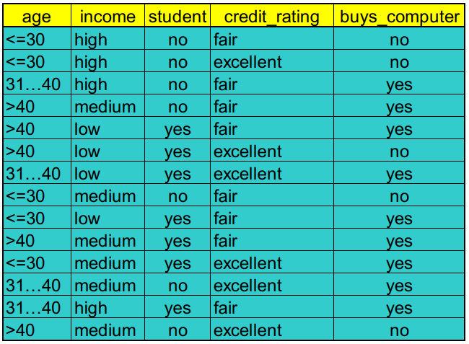

- Write a Python program for two-layer feed-forward neural network and draw the computing unit using single perceptron.

- Write a Prolog program on Resolution Refutation for the “happy student” problem.
1. Anyone passing his history exams and winning the lottery is happy.
2. Anyone who studies or is lucky can pass all his exams.
3. John did not study, but he is lucky.
4. Anyone who is lucky wins the lottery.
Prove that John is happy!

- Write a Prolog program find a person is Mortal or NOT with the following facts.
Socrates, Einstein, Alexander.

man(socrates), man(Einstein), man(Alexander).

